Trader Guide

This guide provides a step-by-step walkthrough of the Trader Management Application, designed to help traders manage their products, transactions, and profiles efficiently. Follow the steps below to navigate the application.

This page Shows welcome screen and navigation bar.

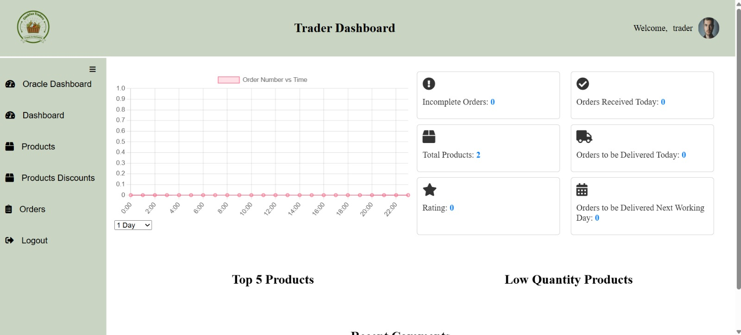

Then we can enter into Product details , to know about product

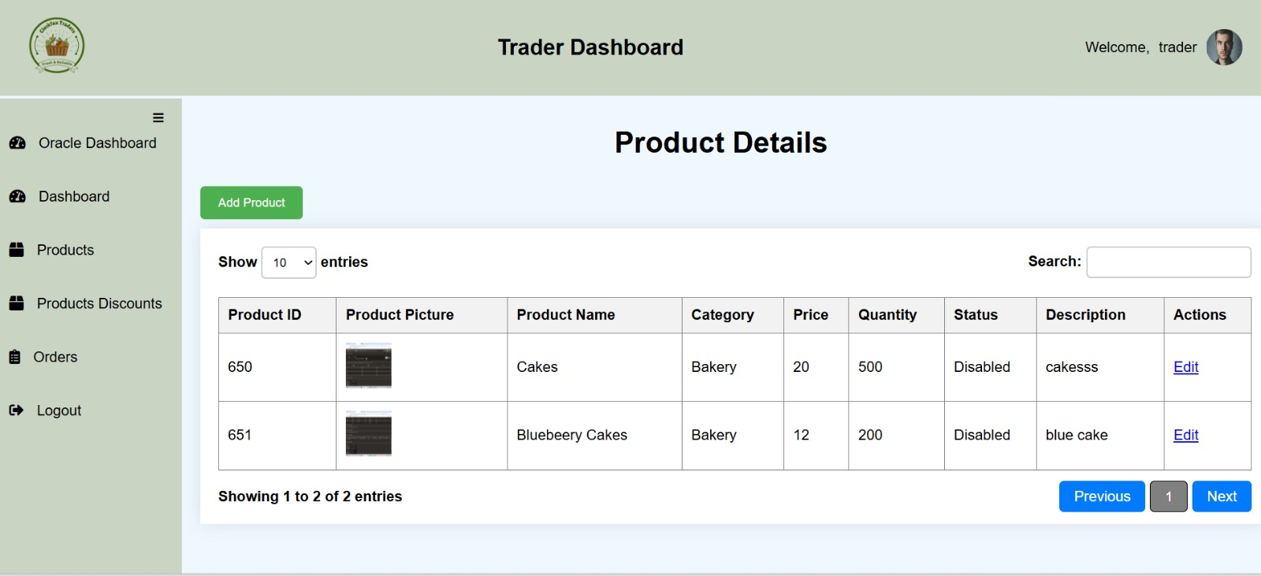

This page let the trader to add the New product , update and even delete.

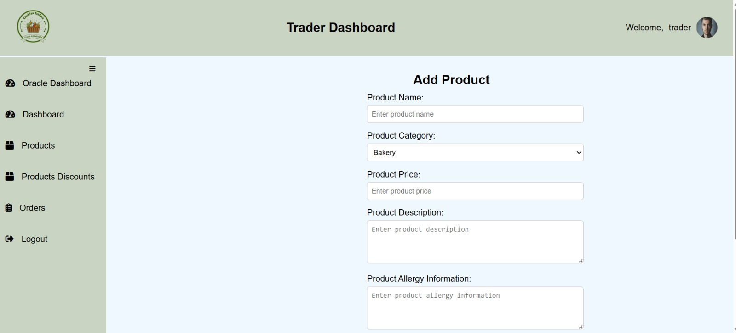

Then we have discount page too; which also a trader can provide to the customer.

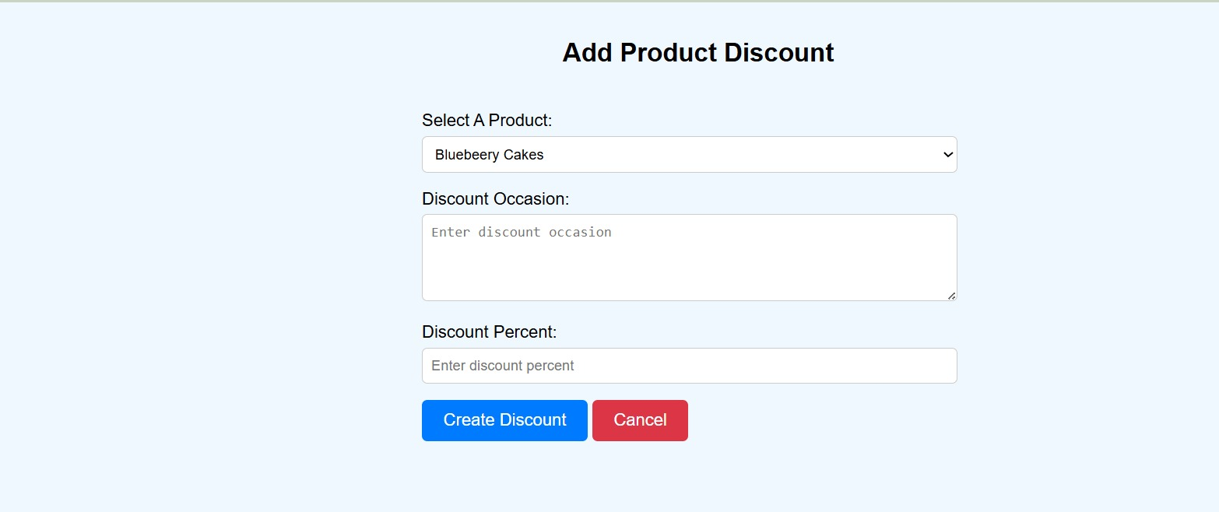

Here is the product Discount details; which show the product discount details

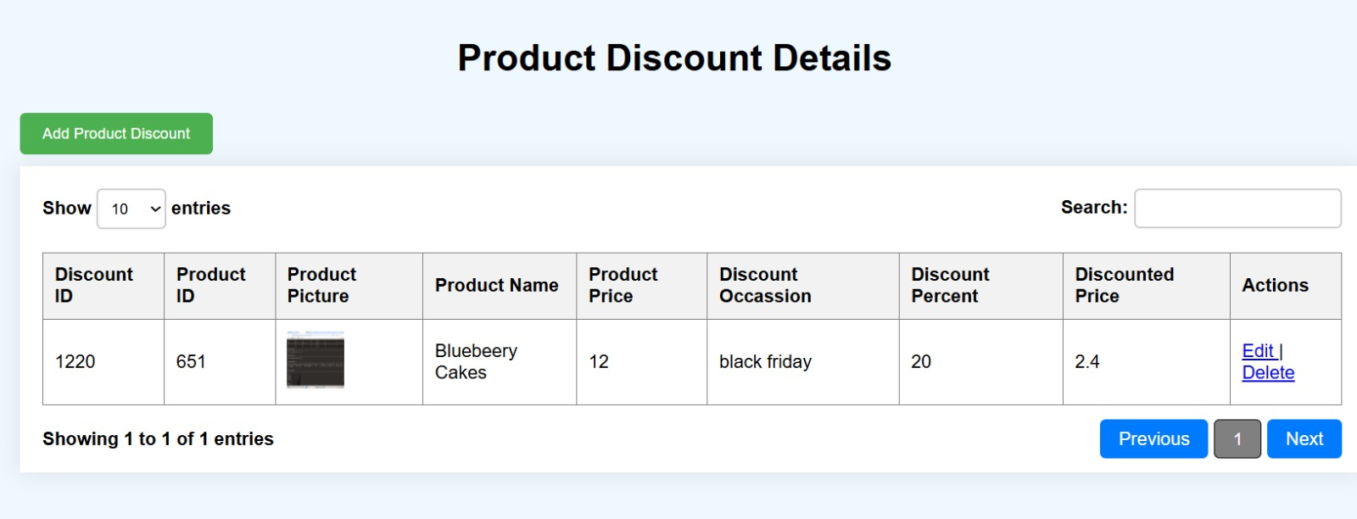

And can also view the orders details

